Dusk At The Farm Evening Visits

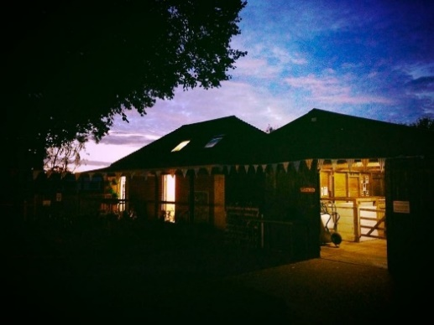
‘Dusk at the Farm’ are our evening community visits.
These farm sessions are perfect for Brownies, Guides, Beavers, Scouts, Youth clubs, and other community organizations.
They give groups a chance to feed our field animals supper and put them to bed (Our goats and sheep love the attention they get)
To meet our poultry, hunt for eggs and feed them their evening corn. Penny our pig has her bedtime supper before she snuggles up in her pig house and when this is done we take a stroll around our farm into the gardens as the sun being to set.
After a drink and a snack, we then have small animal encounters with our nocturnal family and reptiles. Get to see our hedgehog Nigel, have a hold of our snake Ursula, meet our Gecko Glinda, and our African snails Spud and Waffle as well as our other mammals and reptiles.
If there is something in particular you wish your group to do please let us know so we can cater for your evening accordingly.
Cost:
The session fee is £100 for a group of up to 18. Extra children are £3.50 each (1 leader free with every 5 children) Maximum of 25 children.
Duration:
The session lasts 2 hours with a break for a snack.
Health and Safety:
Our experienced Educational Coordinator Rachel Thomson runs educational visits.
All farm staff are List 99’d and have an enhanced DBS check, as do our volunteers that
Work closely with the Educational Day classes. Staff are trained in CEVAS (Countryside
Educational Visits Accreditation Scheme) and Rachel has been fully trained in First Aid.
We will provide a Health and Safety talk before we begin the activities and will remind all
Pupils to wash their hands before eating and leaving the farm. Everywhere on the farm
is a strict ‘no smoking’ area. On our website is a link to 3 useful guides for teachers
Regarding Code of Practice when visiting a farm, provided by Farming and Education
Website www.visitmyfarm.org. You must read these to reduce potential risk when visiting
the farm.

Facilities:
The farm building is fully wheelchair accessible and has disabled toilets. The main building houses the small animal room that is be ideal for wheelchair users. Parts of the farm are accessible to all but in specific areas there is uneven terrain, so we recommend you call us for further details.
Location:
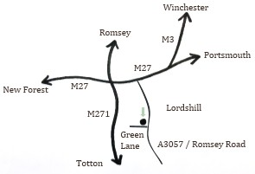
We are easy to get to. The farm is based in Millbrook, Southampton, close to the Oasis Pre-School and Compass School. There is ample free parking and if it gets too busy then we have access to tennis courts as an overflow car park.

We are 5 minutes from the M271 and M27 by car. If travelling by train, we are a 15-minute car drive away from Southampton Central station. The number 4 ‘Bluestar’ bus stops every half hour on Green Lane (where the farm is situated).

Contact us:
Want to visit the farm? Fantastic! Please contact us via the following:

02380 522706
downtoearthfarmlordshill@oasisuk.org
Oasis Down to Earth Farm, Green Lane, Southampton, Hampshire, SO16 9FQ

